Name: Yash Raj
Roll Number: 24k-0737
Task#1 Code:
INCLUDE Irvine32.inc

.data
marks WORD 45, 78, 90, 32, 60, 49, 85
pass WORD 0
fail WORD 0
passing WORD 50

.code
func PROC
mov ecx, LENGTHOF marks
mov esi, OFFSET marks

L1:
mov ax, [esi]
cmp ax, passing
jl failed
inc pass
jmp nextItem
failed:
inc fail
nextItem:
add esi, TYPE marks
loop L1

; Display results
movzx eax, pass
call writedec
call crlf
movzx eax, fail
call writedec

exit

func ENDP

main PROC
call func
main ENDP

END main

Output:
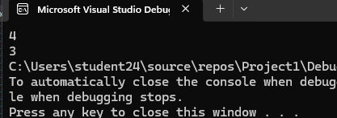

Task#2:
Code:
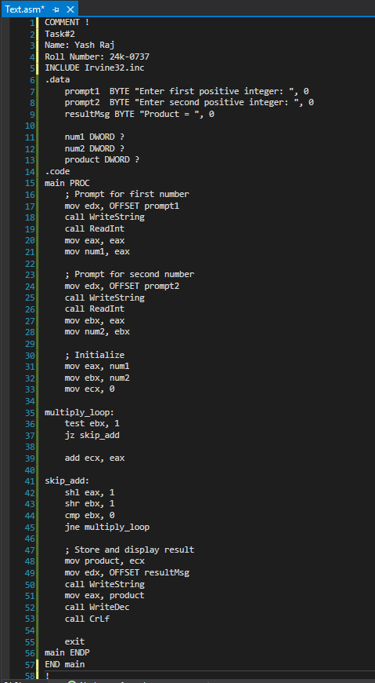

Task#2 Output:
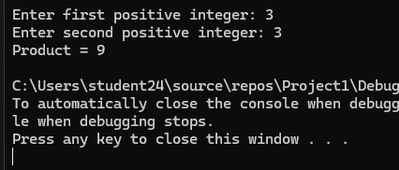

Task#3 Code:
INCLUDE Irvine32.inc

.data
originalValue BYTE 10110110b
encryptedValue BYTE ?
msgOriginal BYTE "Original Value = ", 0
msgEncrypted BYTE "Encrypted Value = ", 0

.code
main PROC
call Clrscr

mov al, originalValue
rol al, 1
rol al, 1
shr al, 1
mov encryptedValue, al

mov edx, OFFSET msgOriginal
call WriteString
mov al, originalValue
call WriteBin
call Crlf

mov edx, OFFSET msgEncrypted
call WriteString
mov al, encryptedValue
call WriteBin
call Crlf

exit
main ENDP
END main
Task#3 output:
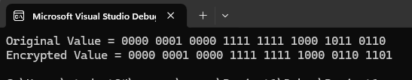

Task#4:
Code:
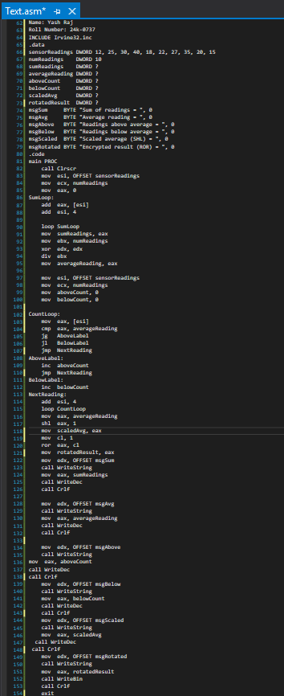

Output:
